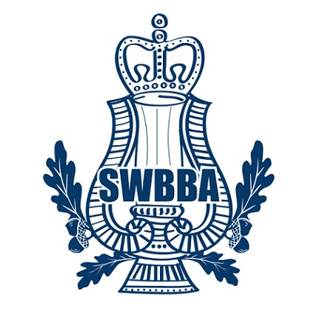
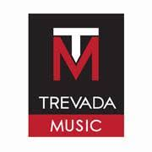
South West Brass Band Association

ONLINE SOLO AND QUARTET CONTEST
ENTRY FORM
Closing Date for Entries 28th February 2021
Class Number | Class Type | Age Group | Entry Fee  NON SWBBA | Entry Fee  SWBBA | Max duration of piece up to | Tick as appropriate
1 | Slow Melody | 12 and under | £4 | £3 | 5 minutes
2 | Slow Melody | 15 and under | £4 | £3 | 5 minutes
3 | Slow Melody | 18 and under | £4 | £3 | 5 minutes
4 | Percussion | 18 and under | £4 | £3 | 5 minutes
5 | Air Varie | 18 and under | £4 | £3 | 8 minutes
6 | Duet | 18 and under | £5 | £4 | 5 minutes
7 | Quartet | 18 and under | £6 | £5 | 10 minutes
8 | Slow Melody | Open | £4 | £3 | 5 minutes
9 | Air Varie | Open | £4 | £3 | 8 mins
10 | Percussion | Open | £4 | £3 | 5 minutes
11 | Duet | Open | £5 | £4 | 5 minutes
12 | Quartet | Open | £6 | £5 | 10 minutes
13 | Ensemble | Open | £7 | £6 | 10 minutes
TOTAL £

Name | Date of Birth (U18 ) / /
Parent Name (U18) | Band Name & Instrument
Address
Telephone number | Email Address
Signature of Entrant | Signature of Parent/Guardian (U18)
Tick to confirm permission given to play your video on social media (all entrants )________ | Tick to confirm parental permission granted for u18 to enter_________
Confirm fee paid to Bank - Sort Code 200459  a/c 63683710 South West Brass Band Association  reference entrants name £___________ or | Tick if cheque attached and sent and confirm amount £_____________ and entry ______  Entrants name written on reverse of cheque

Email entry form to: secretary@swbba.com
If preferred, cheques and Entry Form can be sent to: Mrs G Rogers, Secretary, SWBBA, 58 West Street, BANWELL, Weston Super Mare, BS29 6DB. Please remember to write the entrants name on the reverse of cheque.
Under the General Data Protection Regulation (GDPR) all personal information supplied on this form will be used solely for the purposes of the Contest Administration, kept securely and destroyed after the event.

