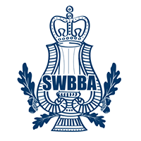
SOUTH WEST BRASS BAND ASSOCIATION

74th ANNUAL CHAMPIONSHIPS – 5th NOVEMBER 2022
RIVIERA INTERNATIONAL CONFERENCE CENTRE, TORQUAY, TQ2 5LZ

ENTRY FORM

Name of Band _________________________________________

Current Grading Section: _____________

Section/s entered (please tick):

Open (Champ/1st) Second Third

Fourth Youth Training

Name of Conductor at Contest (block capitals): ____________________________

Name of Secretary (block capitals): _______________________________________

Email: ______________________________________________________________

Telephone: ______________________________________

Entry Fees:
Open, Second, Third, Fourth/Ungraded for SWBBA member bands is £175 and for non-member bands is £195.

Youth and Training for SWBBA member bands is £65 and for non-member bands is £90.

Payment of entry fee is preferred by bank transfer to:
‘South West Brass Band Association’; Sort code; 20 04 59; A/c no: 63683710 stating band name as a reference.

Cheques to be sent with entry form to the Contest Secretary at 58 West St, Banwell, Weston super Mare, BS29 6DB, or email entry form to secretary@swbba.com

Please tick: Bank Transfer made or cheque sent

Entries will only be accepted once payment has been made.

Closing date for entries is Friday 16th September 2022.

